Nutrition News: March: What is a Portion?
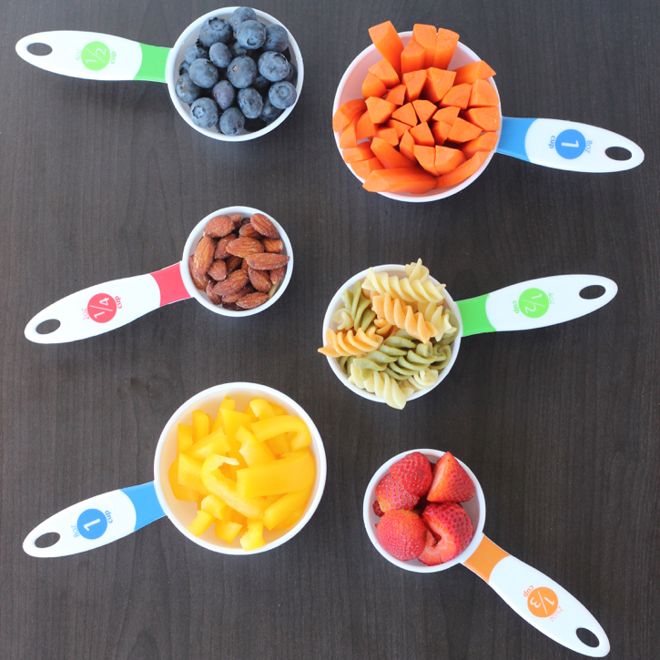
What is a food portion?
- The key to eating healthy is knowing and choosing appropriate amounts of different types of food. The term “portion size” and “serving size” are often thought to mean the same thing, however, they don’t.
- Serving size is a standard of measure for foods. It means the portion of food used as a reference on the nutritional label of that food or, the recommended portion of food to be eaten.
- Portion size is simple; it’s the amount of food you eat which may be more or less than a recommended serving size.

Estimated portion sizes:
- Using measuring spoons and cups is the best way to make sure your portion is the same as a serving size. However, these tools are not always available so another way to estimate your portion is by comparing it to something else.
- 1 teaspoon = the tip of the pointer finger or a postage stamp-this portion is often used for oils and fats.
- 1 tablespoon = the size of the thumb-this portion is often used for peanut or nut butters.
- 3 ounces = the palm of the hand or a deck of cards – this portion is often used for fish, chicken, beef or other meats.
- 1/2 cup or 4 ounces = small scooped handful or tennis ball – this portion is used for grains, such as rice, pasta and oatmeal.
- 1 cup = average sized fist or baseball – this portion is often used for raw or cooked vegetables, whole fruit or 100% fruit juice.

Ways to monitor your portions:
Read the Nutritional Fact Label on the food package to identify the appropriate serving size.
Using the right tools for measuring, portion out your food onto a plate and then put the container away.
Eating from a package often leads to consuming more than the recommended serving.
Try using smaller plates and bowls to make portion sizes appear larger.

