Nutrition News: June 2023 Beans, Nuts & Seeds
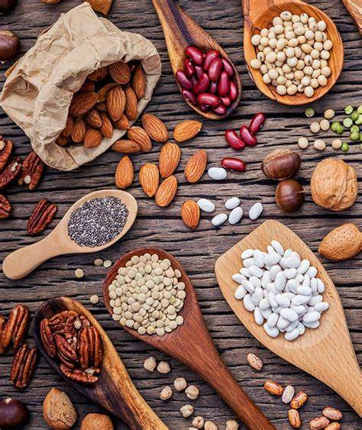
Beans, Nuts & Seeds:

Beans, Nuts & Seeds provide healthy monounsaturated and polyunsaturated fats as well as protein. Dried beans also known as legumes, provide a healthy lean protein. A great way to benefit from a healthier plant-based diet that is also packed with vitamins and minerals is to eat beans, nuts and seeds instead of animal meats.

Portions:

Nuts and seeds are rich in vegetable oils which contain nine calories per gram of oil. One ounce (approximately one handful) is the standard serving for nuts and seeds. A half cup of cooked beans contains about 115-125 calories and 7-9 grams of protein.

Other suggested portions include:
- 1/3 cup nuts
- 2 tablespoons peanut butter
- 2 tablespoons seeds
- ½ cup cooked legumes (dried beans or peas)
Mediterranean Diet:

The Mediterranean diet is a healthier way of eating and helps prevent heart disease and stroke. This healthier diet incorporates beans, nuts, seeds, vegetables, whole grains, fruits, herbs and spices and olive oil as the main source of added fat.

Fish, seafood, dairy and poultry are included however are limited, and red meat and sweets are eaten only occasionally.

DASH Diet (Dietary Approaches to Stop Hypertension):

DASH diet is rich in vegetables, fruits and whole grains, beans and nuts, low-fat dairy products, poultry, and fish. Saturated fats, such as full-fat dairy products and fatty meats are limited. Also limited is sodium to between 1,500 and 2,300 milligrams a day. That amount is mostly found naturally in foods without adding salt to foods.

How To Eat More Beans, Nuts & Seeds:

- Soups such as navy bean, lentil and black bean
- Chickpeas: Hummus with whole grain pita chips
- Soybeans: Tofu stir-fry and tofu lasagna in place of meat.
- Chia seeds over hot or cold cereal or a chia seed smoothie.

