Nutrition News: November 2022 Benefits of Garlic
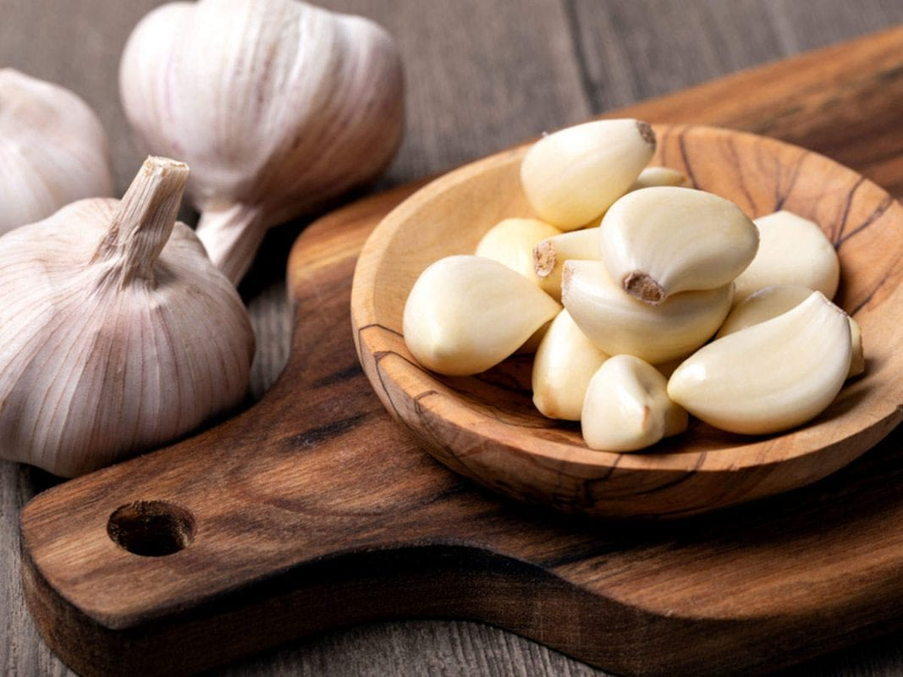
What is Garlic?
Garlic is a species in the onion group, Allium. Close relatives include chive, onion, shallot, and leek. Most of the health effects are caused by one of the sulfur compounds formed when a garlic clove is chewed, chopped, or crushed. This compound is allicin and is also responsible for the distinct flavor of garlic. The minimum effective dose for therapeutic reasons is one clove eaten with meals, two or three times a day.

Health Benefits of Garlic:
- Regularly eating garlic, along with a healthy diet, can substantially lower your risk of colon cancer and various other cancers.
- Garlic oil works as an anti-inflammatory. Rub garlic oil on inflamed and sore muscles and joints. Garlic can also help prevent cartilage damage caused by arthritis.
- Red blood cells turn the sulfur in garlic into hydrogen sulfide gas. This gas expands the blood vessels, making it easier for the body to regulate blood pressure. Check with your doctor before changing or stopping any medications.
- A single clove of garlic contains manganese, vitamin B6, vitamin C, selenium, and fiber.
- Garlic can boost the function of the immune system and reduce the severity of illnesses. Garlic can help protect against illness, including the common cold and flu.
- Improves cholesterol levels by lowering the LDL (bad) cholesterol, which may lower the risk of heart disease.
- Garlic contains antioxidants that can help protect the body against oxidative damage. This may prevent or reduce the symptoms of Alzheimer’s disease and dementia.
- Allicin can fight off bacteria, including some that are resistant to synthetic drugs.
- The antifungal properties have been found to be effective in treating yeast infections.

Garlic is easy to include in your diet:
- Garlic compliments many savory dishes.
- Easy to roast with olive oil and use as a spread.
- Comes in several forms from whole cloves, minced, paste, powders and supplements.
- Press a few cloves of fresh garlic with a garlic press or between a fork, then mix with olive oil. Use as an easy salad dressing.

