Nutrition News: December 2022: 12 Health Tips
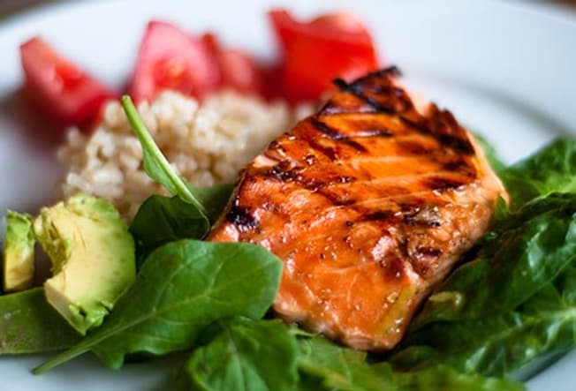
12 Health Tips:
Commit yourself to a healthier lifestyle with these 12 tips.

Breakfast:
Try a breakfast burrito with scrambled eggs, low-fat cheese and salsa in a whole wheat tortilla, with a side of fresh fruit and a serving of non-fat milk or yogurt.

Learn Food Labels:
Learn to read food labels. This will help you to shop and prepare healthier meals.

Watch Portion Sizes:
Use measuring cups and a scale to portion your meals.

Load up your Plate with Fruits & Vegetables:
Fill half your plate with fruits and vegetables and the other half with grains and lean meats and legumes.

Prepare Healthy Snacks:
Healthy snacks can sustain energy levels between meals. Plan snacks that are from two or more food groups. Try raw vegetables with low-fat cottage cheese or peanut butter with a banana or apple.

Be Active:
Regular physical activity has many health benefits. Start by doing a few exercises for 10 minutes at a time a few times a day.

Cooking with others:
Cooking with others can be a fun way to try new foods and help split the cost of food.

Cut Back on Added Sugar:
Food & drinks with added sugar add empty calories. Read the food label ingredients to identify sources of added sugar.

Try Plant-Based Foods:
Many recipes that use meat and poultry can be made with plant-based substitutions. Try one meatless meal per week to start.

Drink More Fluids:
Drink more water instead of sugary drinks. Staying well hydrated by drinking plenty of water is important to staying healthy.

Increase your Seafood:
Fish and shellfish contain a variety of nutrients including healthy omega-3 fats.

Try New Foods & Flavors:
Add more nutrition and eating enjoyment by expanding your range of food choices. When shopping, select a fruit, vegetable, or whole grain that’s new to you.

