Nutrition News: August 2023 Eating Healthy on the Run
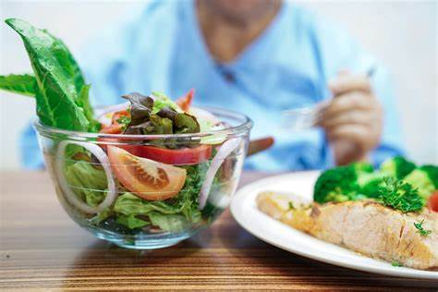
Eating Healthy on the Run:
Most Americans eat out a lot. People are looking for fast, easy, and good-tasting foods to fit their busy lifestyle. Whether it’s to-go orders, food courts or sit-down restaurants, there are healthier choices everywhere.

Tips to help you eat healthy on the run:
- Think ahead and plan where you will eat. Consider what meal options are available where you are going. Look for a restaurant or carry-out that has a large range of menu items.
- Take time to look over the menu and make careful selections. Some restaurants may have a menu section indicating “healthier” options.
- Carefully read the menu for words that give clues to calorie and fat content. Words that can mean less fat and calories: braised, baked, grilled, broiled, roasted, steamed, and poached.
- Menu terms that can mean more fat: fried, battered, creamed, crispy, breaded/battered, and buttered. Choose these foods only on an occasion in small portions.
- It’s OK to make special requests, keep them simple. For example, ask for a baked potato instead of mashed or French fries; no mayonnaise or bacon on the sandwich; sauce or dressing on the side.
- Hunger can cause you to eat too much bread before the meal is served. Hold the bread or chips until your meal is served.
- Limit the amount of alcohol you drink. No more than one drink for women and two for men. Alcohol tends to increase your appetite and provides calories without any nutrients.
- Boost the nutrition in sandwiches by adding lettuce, tomato, pepper, avocado or other vegetables.
- In place of fries and chips, choose a side salad, fruit, or baked potato.
- Eat the lower-calorie foods first. Soup or salad is a good choice. Follow up with a light main course.
- Look for a sandwich wrap in a soft tortilla. Fillings such as rice or beans mixed with chicken, seafood or grilled vegetables are usually lower in fat and calories.
- Load up your pizza with vegetable toppings. If you add meat use lean meat such as chicken, shrimp, lean low sodium ham or Canadian bacon.
- Always eating on the go? Stash portable, nonperishable foods in your bag, jacket, backpack, or tote. Some options are granola bars, fresh fruit, trial mix, single serve package of whole grain crackers, cereal or peanut butter and crackers.
- Be size-wise about muffins, bagels, croissants, and biscuits. A jumbo muffin has more than twice the fat and calories of the regular size muffin.

