Nutrition News: September 2023 Powering up with Breakfast
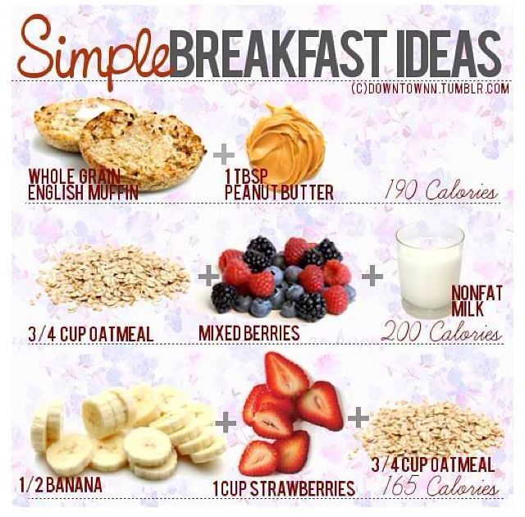
Healthy Start to the day:
A healthy breakfast is important for everyone as it provides the energy needed to start the day. Here are some quick breakfast ideas.

Yogurt: a good protein source; Greek yogurt has more protein than regular yogurt.

Eggs: great protein source with vitamins and other nutrients. Although yolks are high in cholesterol, they don’t appear to increase the risk of developing heart disease.

Whole grains: High fiber whole grain cereals and breads can help keep your blood sugar in line and avoid the mid-morning energy crash. Bran cereal, bran flakes, and steel-cut oatmeal are typically the healthier cereals.

Tips to help you start a healthy day:
- Layer low-fat plain yogurt with your favorite crunchy cereal such as Grape Nuts and top with fresh blueberries, strawberries, or raspberries.
- Make a breakfast smoothie with low-fat milk, wheat germ, tofu, frozen berries and frozen banana, and low-fat plain yogurt.
- Prepare instant plain oatmeal with low-fat milk instead of water. Top with dried cranberries, raisins and chopped walnuts.
- Prepare one packet of instant plain oatmeal with low-fat milk. Mix in 1/4 cup unsweetened applesauce and dust the top with cinnamon or pumpkin pie spice.
- Toast a whole grain bagel and spread with low-fat cream cheese and top with sliced strawberries.
- Top pancakes or waffles with low-fat yogurt and fresh or canned peach slices.
- Spread all-natural peanut butter on a whole wheat flour tortilla. Add a banana and roll up.
- Stuff a whole wheat pita with scrambled eggs or sliced hard cooked eggs and low-fat Swiss cheese.
- Toast a whole grain bagel and top with low sodium lean ham or Canadian bacon and low-fat Swiss cheese.
- Fill a bowl halfway with your favorite nugget cereal, add 100% bran cereal, toasted sunflower seeds, toasted sliced almonds, sliced banana, raisins, and your favorite fresh berries. Mix in 1 cup strawberry or raspberry low-fat yogurt.
- Take leftover rice and mix with low-fat yogurt, dried unsweetened fruits and chopped walnuts and dust the top with cinnamon.
- Toast whole grain bread and spread all-natural peanut butter and top with sliced bananas and strawberries.

